Atomic Structure
Name: |  |  | Use in Conjunction with class powerpoint
Class: |  |  | Nelson Textbook: pp: 104-110
Period: |  |  | Review Questions 1.1, 1.2
Date:
The Structure of an Atom
Multiple Choice
Carefully read each question and then circle the letter of the correct answer.
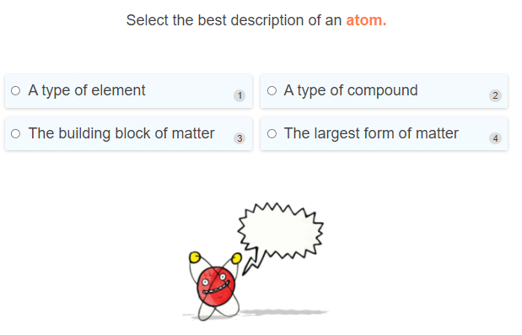
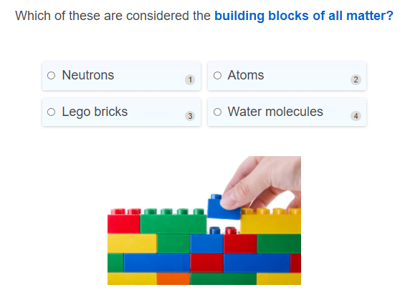
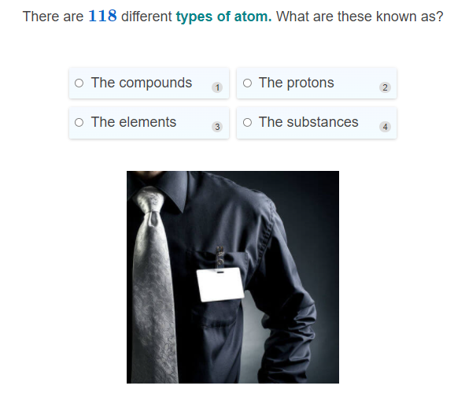
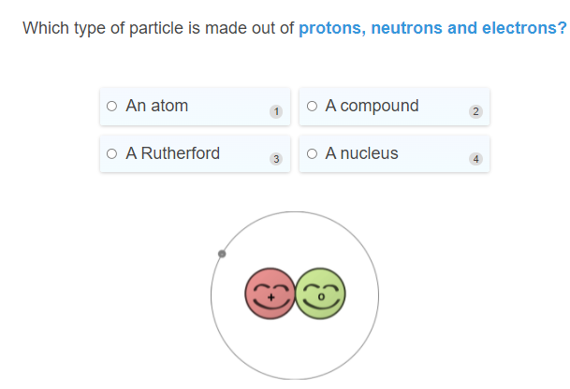
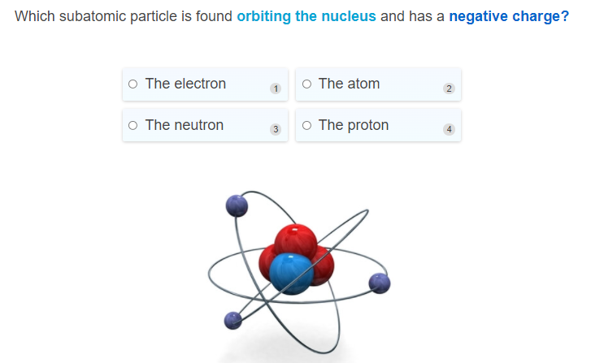
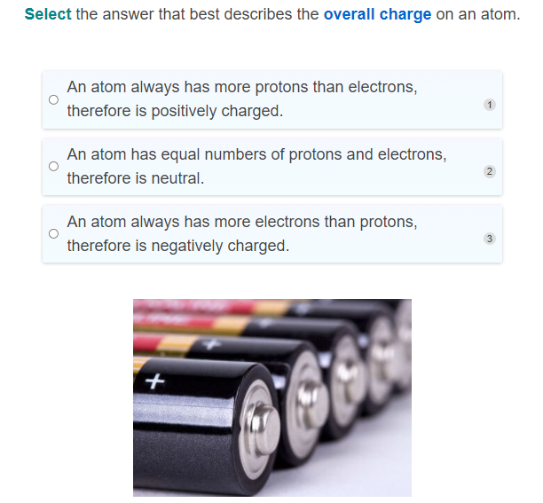
Short and Long Answer
- On the diagram below, draw lines beteen the labels and the correct particles within the atom.
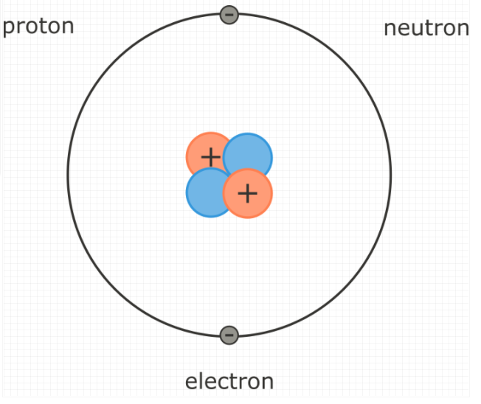

- Explain how the different particles within an atom contribute to the overall mass of the atom. In your answer:

Describe the relative masses of each of the particles that make up an atom.
Explain how these determine the overall mass of the atom.

- Briefly describe the three subatomic particles that make up atoms, and how they contribute to the overall charge on an atom. In your answer you should:
Name the three subatomic particles that make up atoms.
State their location within an atom and their charge.
State the overall charge on an atom, and explain why it has this charge.

Atomic Number
Multiple Choice
Carefully read each question and then circle the letter of the correct answer.
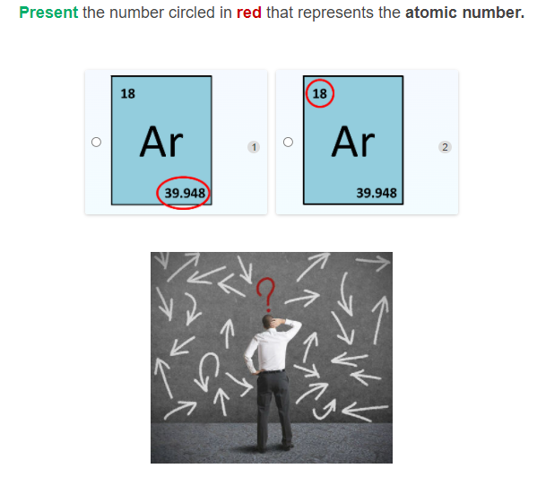
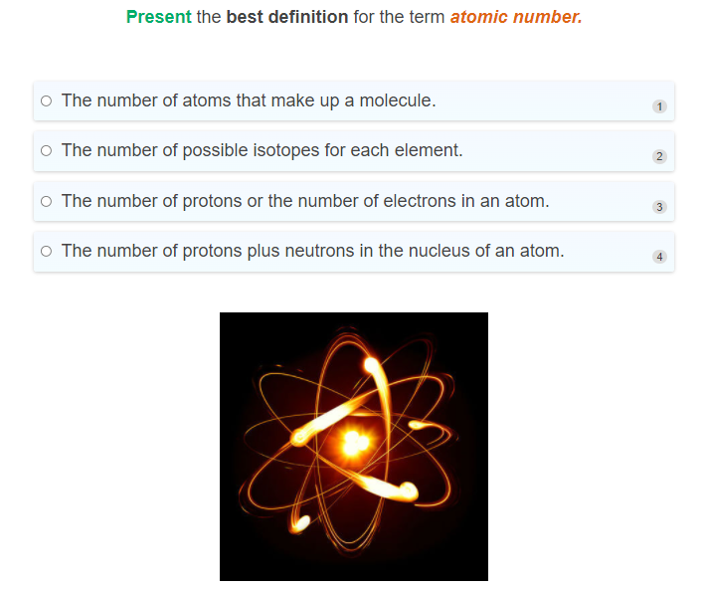
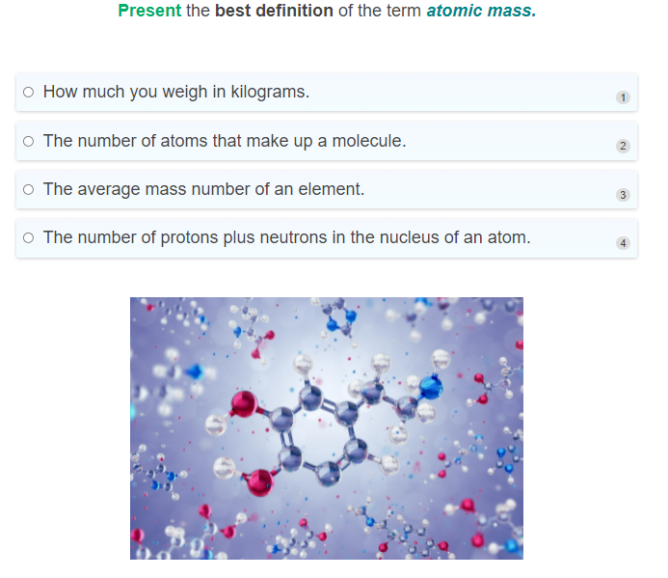
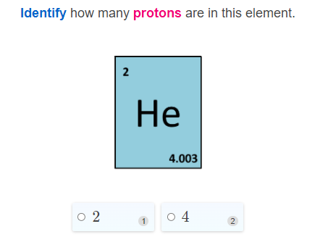
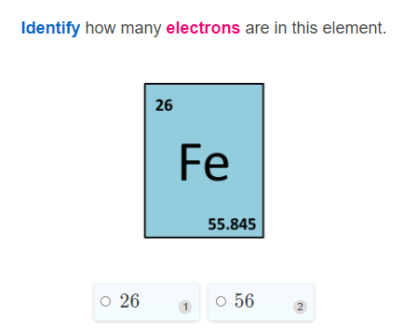
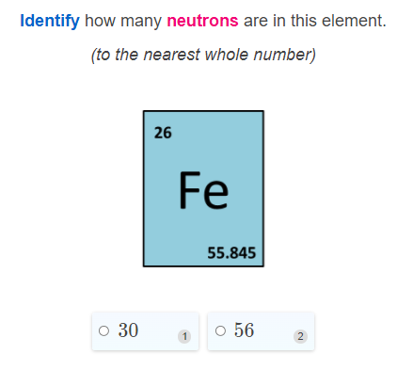

Short and Long Answer

- Select the correct words to fill in the spaces below.
protons electrons
The atomic number is defined as the number of ______________ in an element.
Due to the fact that atoms are neutral, the atomic number also tells us how many ______________ are in an element.
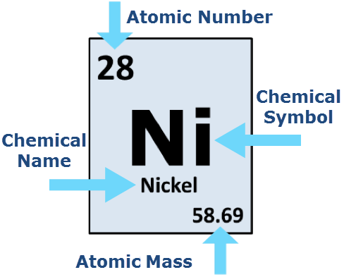

- Select the correct words to fill in the spaces below.

number atomic electrons protons mass neutrons

The number of protons in the nucleus of an atom is called its _____________ number. This is also equal to the number of _____________ in the neutral atom. The atomic _____________ is the average number of protons and _____________ in an element.

The mass _____________ is the number of ______________ and neutrons in an atom, but a single element can have atoms of several different mass numbers.

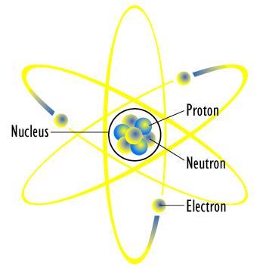
- Select the correct words to fill in the spaces below.

neutrons protons atomic mass
The _______________ number of sodium (Na) is 11. This means it has 11 _____________ in the nucleus and 11 electrons in its orbitals.

The atomic ___________ of sodium is 22.99. Since it has 11 protons, this means most sodium atoms have 12 ______________ in the nucleus.
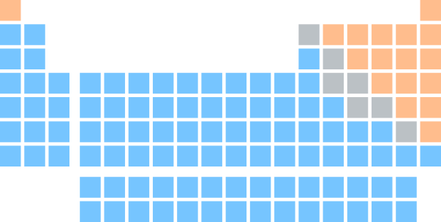

- Briefly describe how symbols are selected to represent elements.
For examples, refer to hydrogen (H), helium (He) and gold (Au)

What are Isotopes?
Multiple Choice
Carefully read each question and then circle the letter of the correct answer.
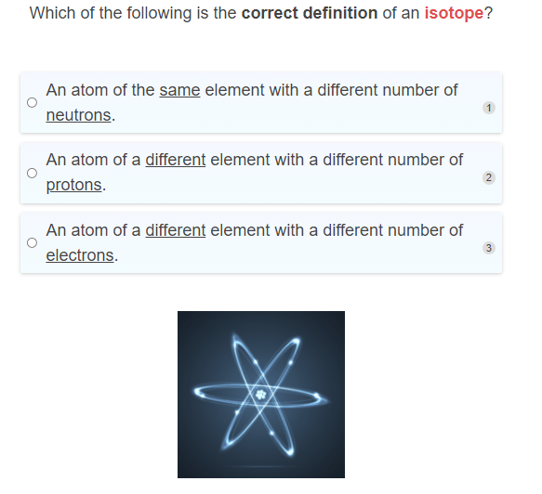
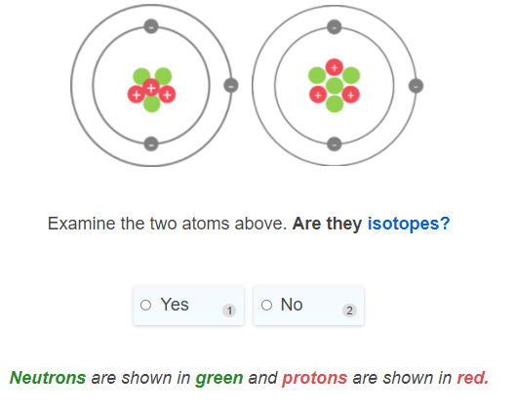
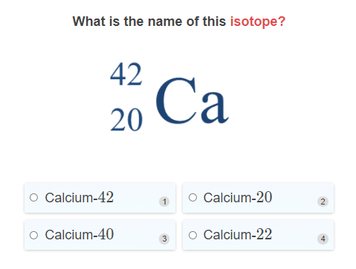
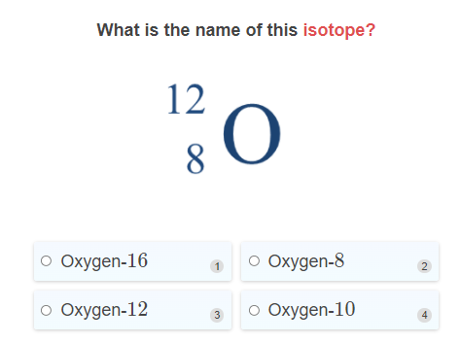
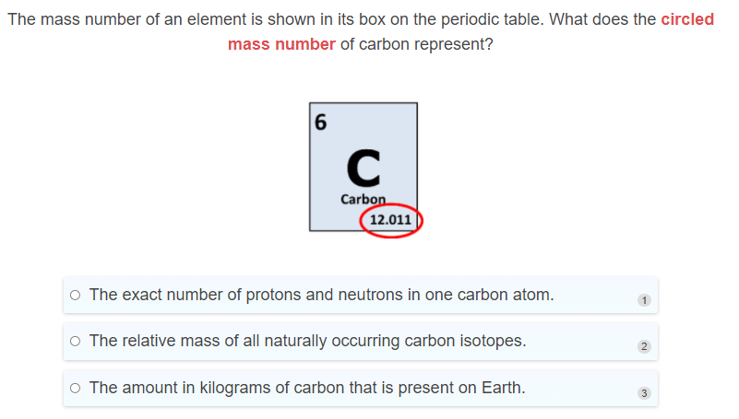
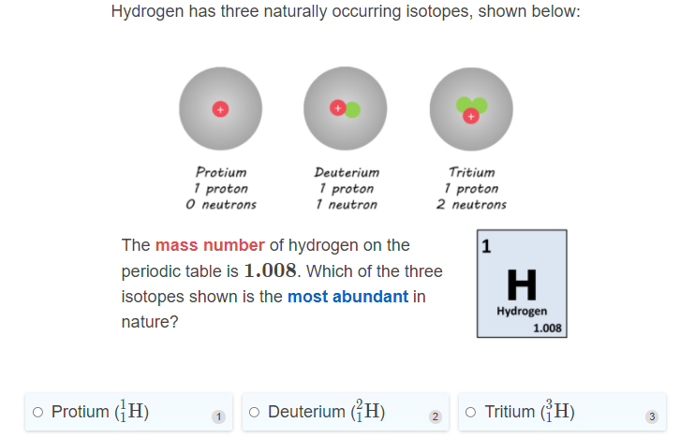
Short and Long Answer
- Nitrogen has two stable isotopes, nitrogen-14 and nitrogen-15. Explain what is different and what is the same between the two isotopes, in terms of their subatomic particles.
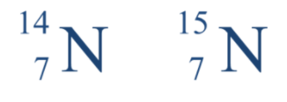
Use the following keywords in your answer: proton, neutron, electron, atomic number, mass number.

